**Write a mapreduce program use map side join to join the two datasets and find What kind of problems are prevalent, and in which state?**

**ANSWER:-**

**Driver class:-**

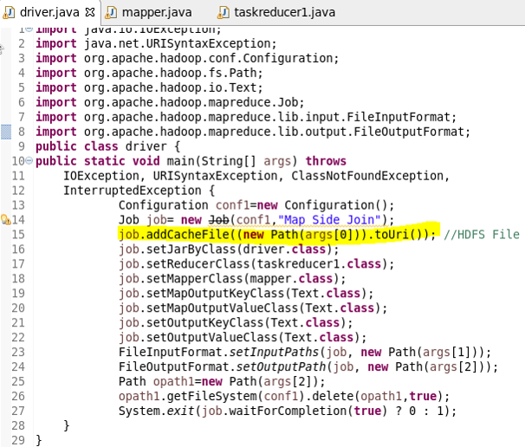

**Mapper class:-**

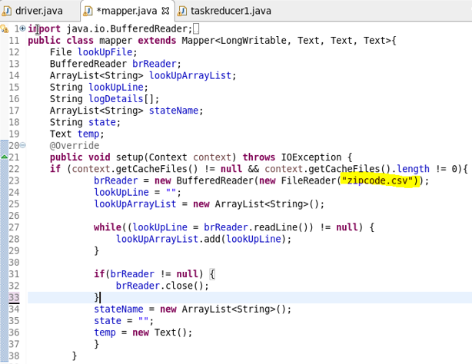

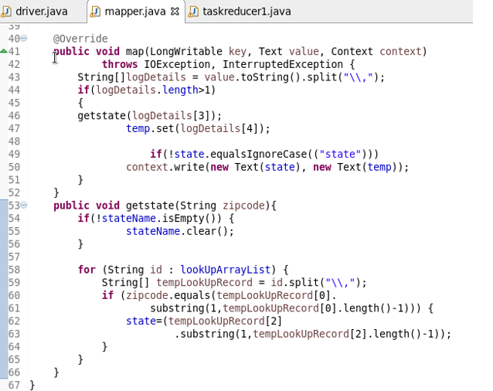

**Reducer class:-**

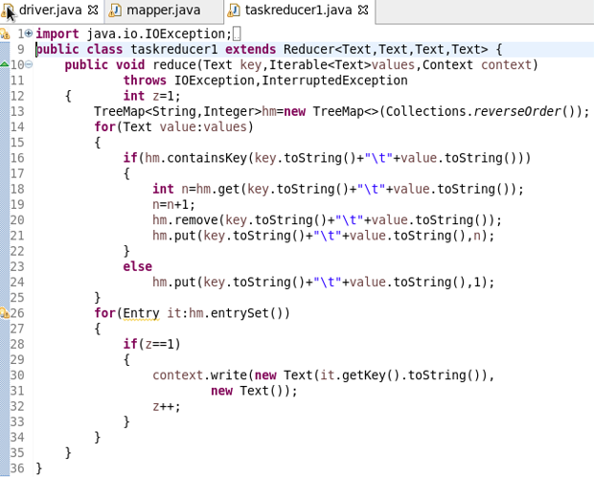

**Running jar:-**

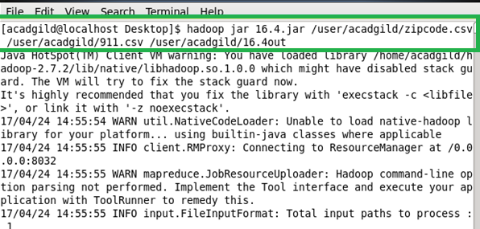

**Output:-**

